Nama : Nayottama Satya Hutama

NIM : 18090004

Kelas : 5C

PRAKTIKUM 2

1. Source code

Latihan1.php => controller

Latihan2.php => controller

Model1.php => model

view-latihan1.php => View

1. URL

[http://localhost/Pustaka_Booking_Nayottama/index.php/Latihan1/penjumlahan/10/7](http://localhost/Pustaka_Booking_Nayottama/index.php/Latihan1/penjumlahan/5/7)

[http://localhost/Pustaka_Booking_Nayottama/index.php/Latihan2/penjumlahan/10/7](http://localhost/Pustaka_Booking_Nayottama/index.php/Latihan2/penjumlahan/10/15)

1. Capture Output Program

latihan1.php

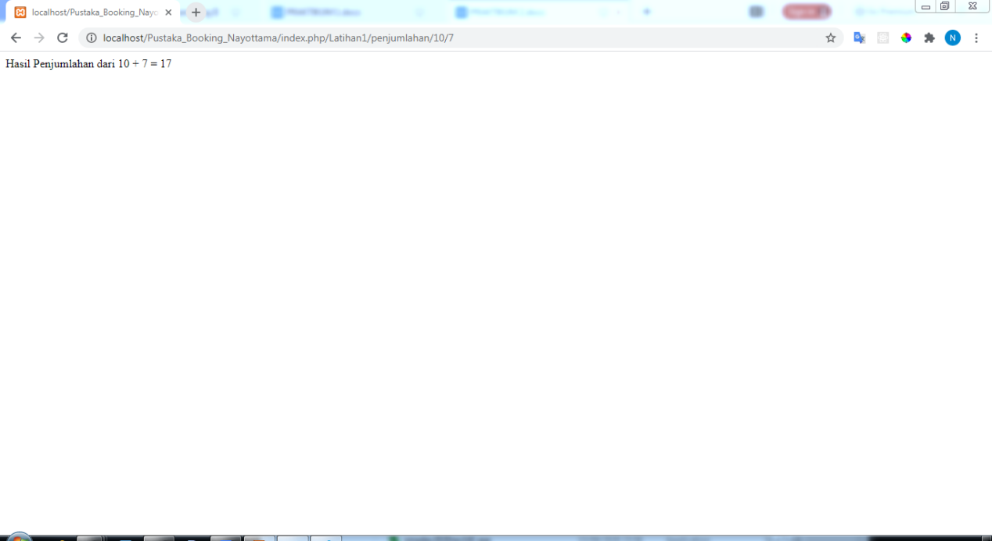

latihan2.php

